CS 340 README Project Two

About the Project/Project Title
This project is a full-stack dashboard application that was developed for the company, Grazioso Salvare. This company is an international search and rescue training organization. This dashboard allows its users to filter the data in order to visualize the data coming from shelters in Austin, Texas. It can be used to identify the most ideal candidates for training based on a few components (breed, age, etc.)

Motivation
The motivation for this program is to allow users to easily filter data in order to find the most ideal candidates for water rescue, mountain/wilderness rescue, and disaster recovery.
The extra features in this app, such as the shelter’s location on a map and the chart showing the distribution of different dog breeds, allow the user to easily find the information necessary and save time in the long run due to the program identifying the best candidates in seconds.

Getting Started
In order to replicate this project, the following would need to be done:
-Clone the project from the repository on GitHub
-Ensure Python is installed
-Install the required packages for Python
-Run the ProjectTwoDashboard.ipynb
-Select a row from the table in order to view the chart paired with a map

Installation
The tools needed for this project would be the following:
-Python (can be installed from their website)
-Jupyter would need to be installed if the user isn’t using a tool like codio
-pymongo
-dash

Usage
The program can be utilized by running the app and selecting to open it from the link it spits out. Once the dashboard is accessed, the radio buttons can be selected in order to filter the data by the ideal candidates for a specific rescue type, like water rescue or disaster. The interactive table updates based on the filter selected and if the circle is checked on a particular animal, the graph will update with their location. The pie chart updates following the filtering of the data with the breed distribution for that type of rescue.

Code Example
@app.callback(Output('datatable-id','data'),
[Input('filter-type', 'value')])
def update_dashboard(filter_type):
if filter_type == 'water':
query = {
"breed": {"$in": ["Labrador Retriever Mix", "Chesapeake Bay Retriever", "Newfoundland"]},
"age_upon_outcome_in_weeks": {"$lte": 104}
}
elif filter_type == 'mountain':
query = {
"breed": {"$in": ["German Shepherd", "Alaskan Malamute", "Old English Sheepdog", "Siberian Husky", "Rottweiler"]}
}
elif filter_type == 'disaster':
query = {
"breed": {"$in": ["Doberman Pinscher", "German Shepherd", "Golden Retriever", "Bloodhound", "Rottweiler"]}
}
else:
query = {}

result = db.read(query)
filtered_df = pd.DataFrame.from_records(result)
if '_id' in filtered_df.columns:
filtered_df.drop(columns=['_id'], inplace=True)

return filtered_df.to_dict('records')

Tests/Screenshots
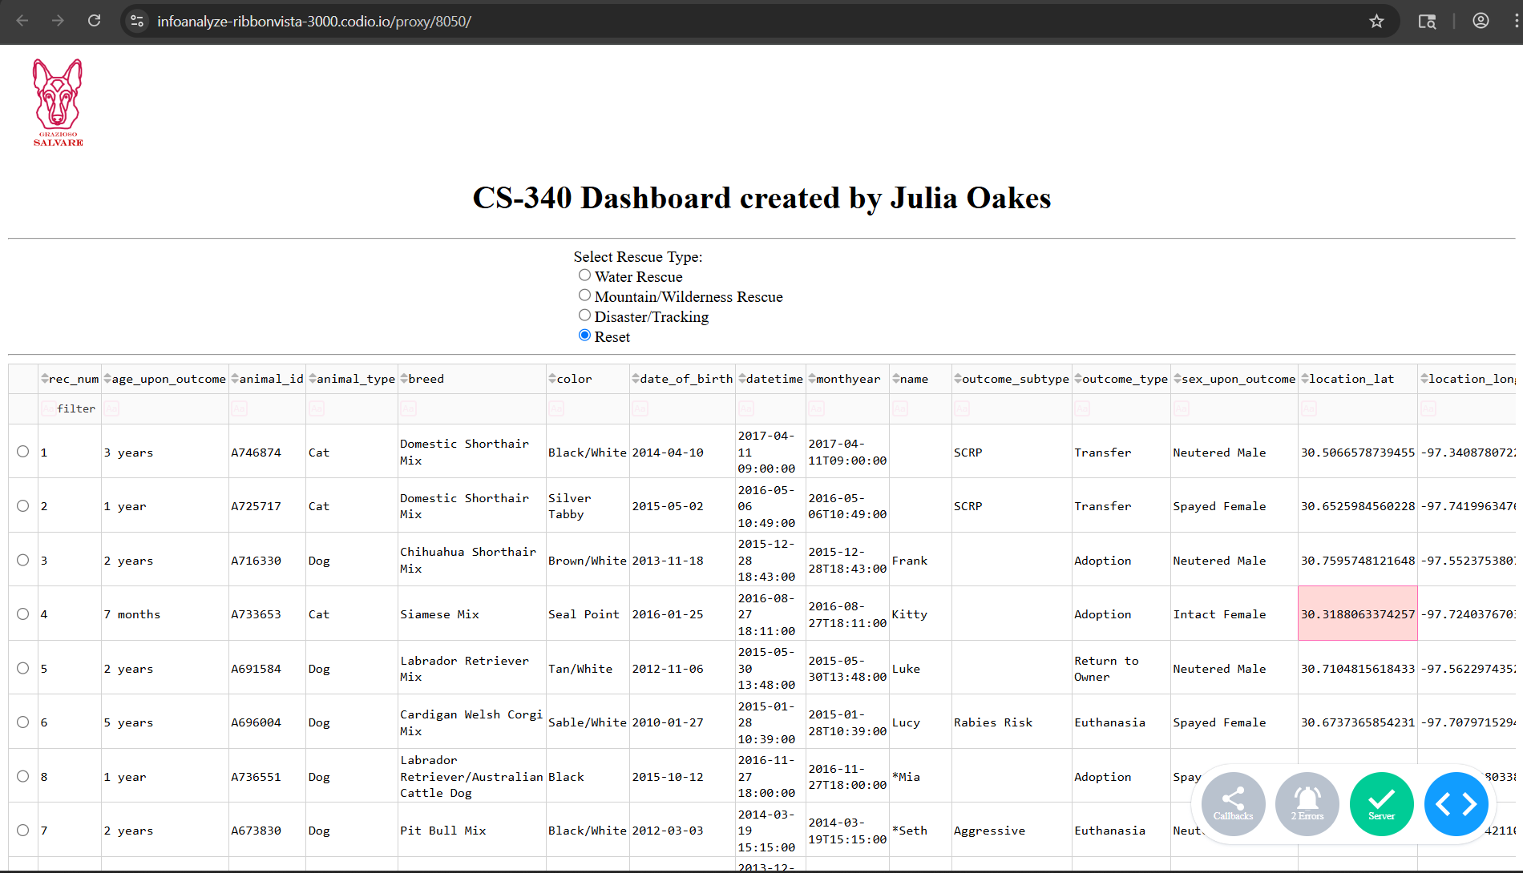
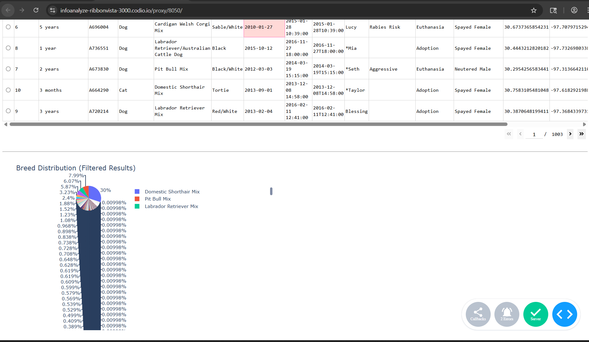
*This is with no filters selected
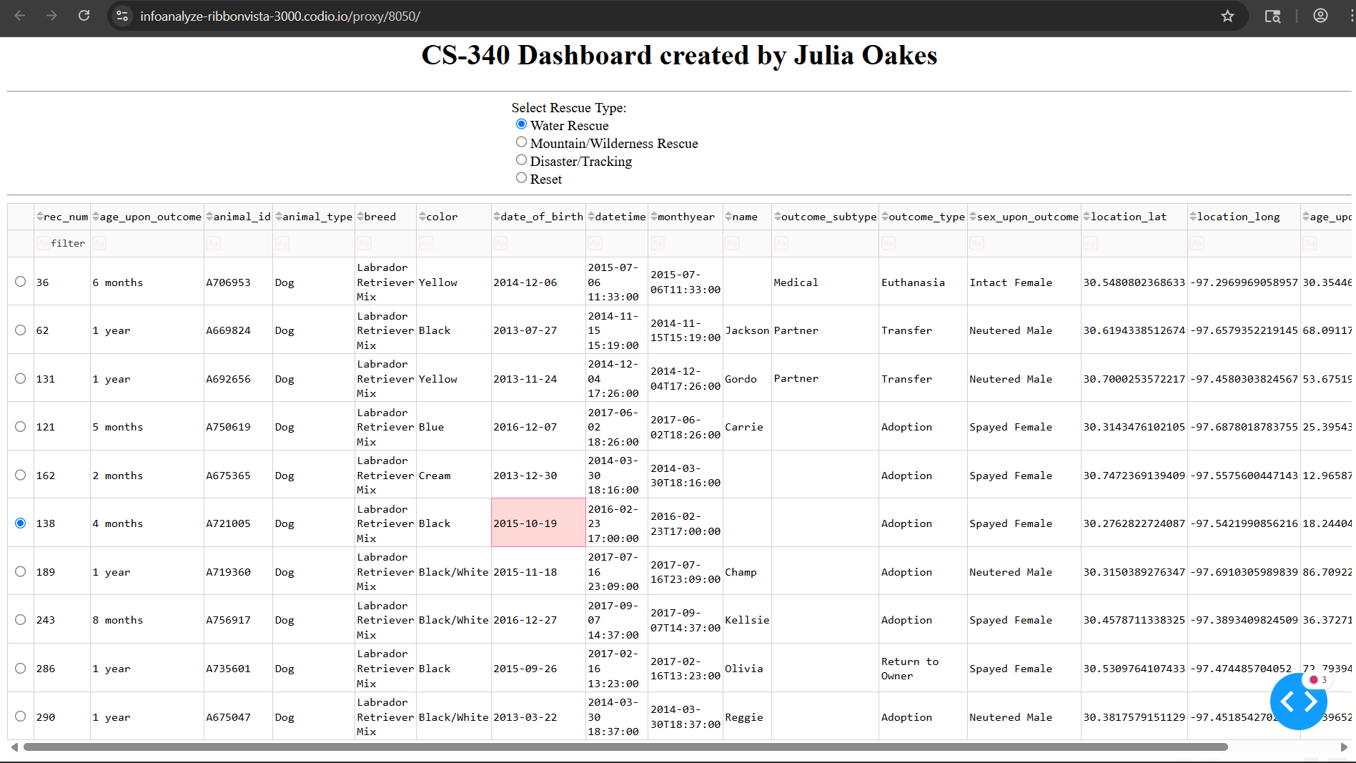
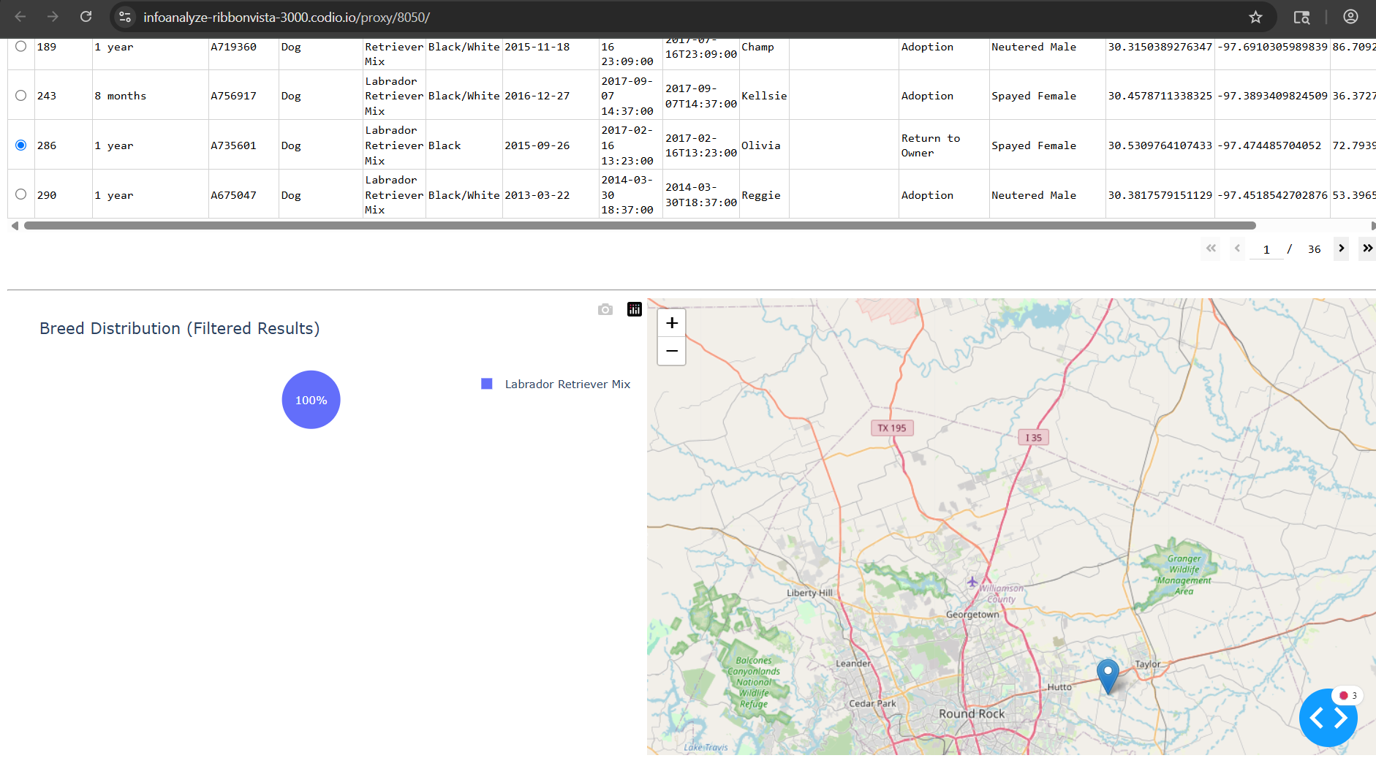
*This was with “Water Rescue” selected as well as a specific dog chosen to demonstrate the map functionality.
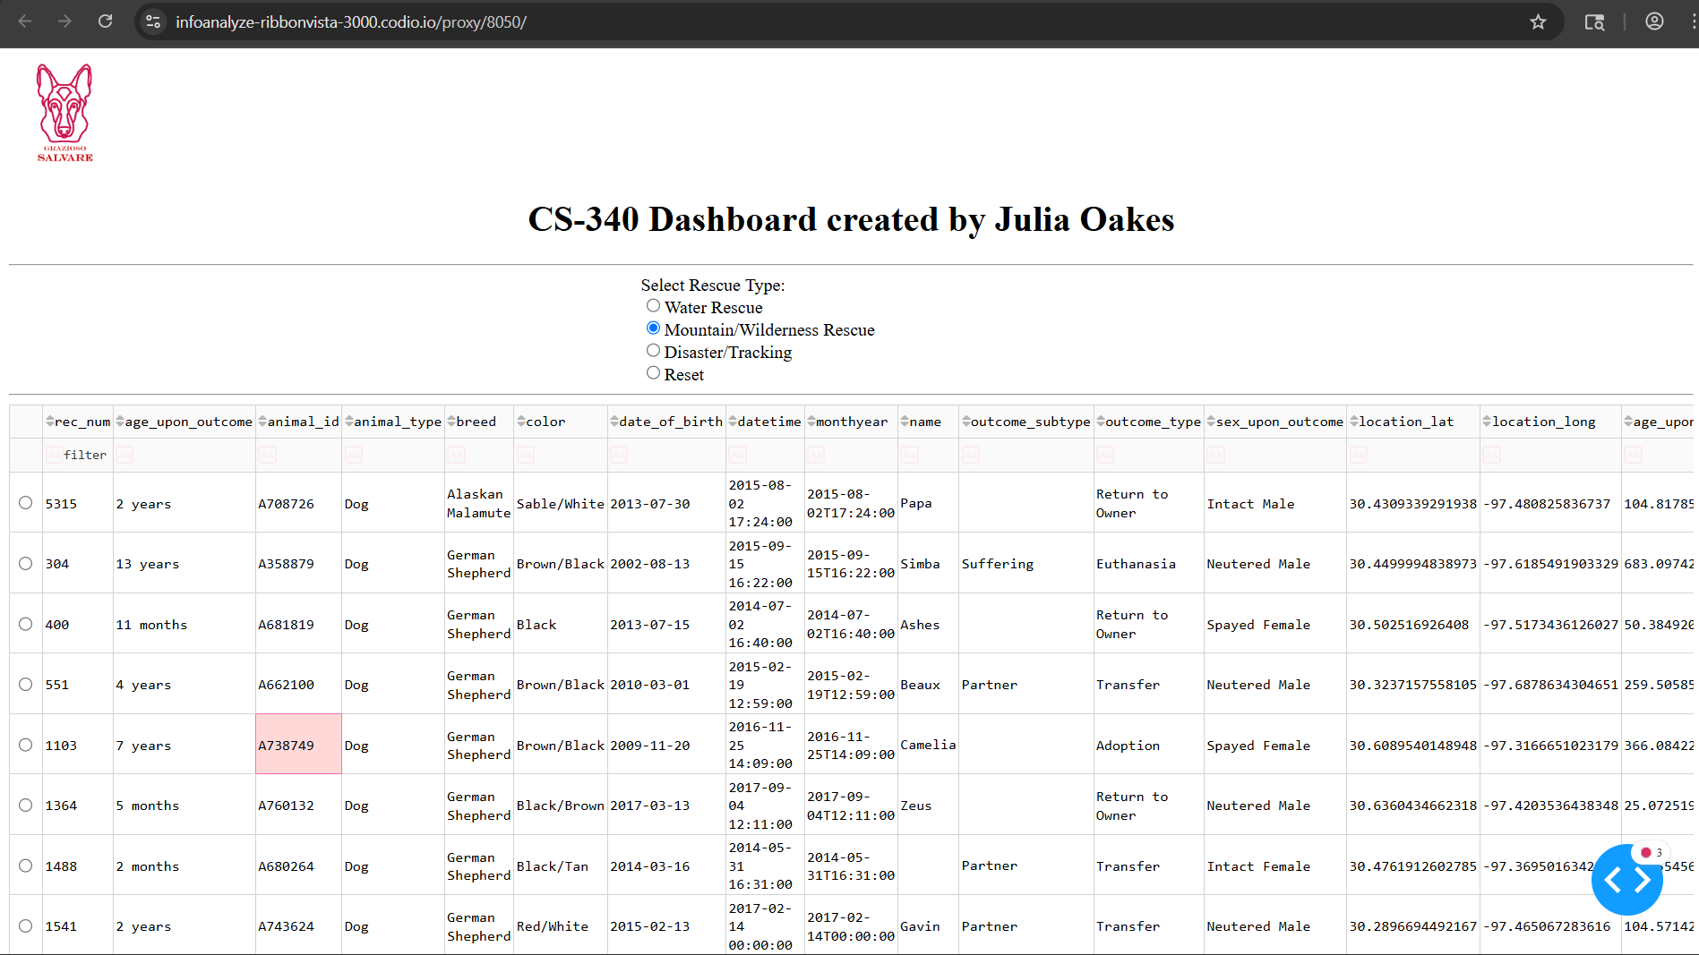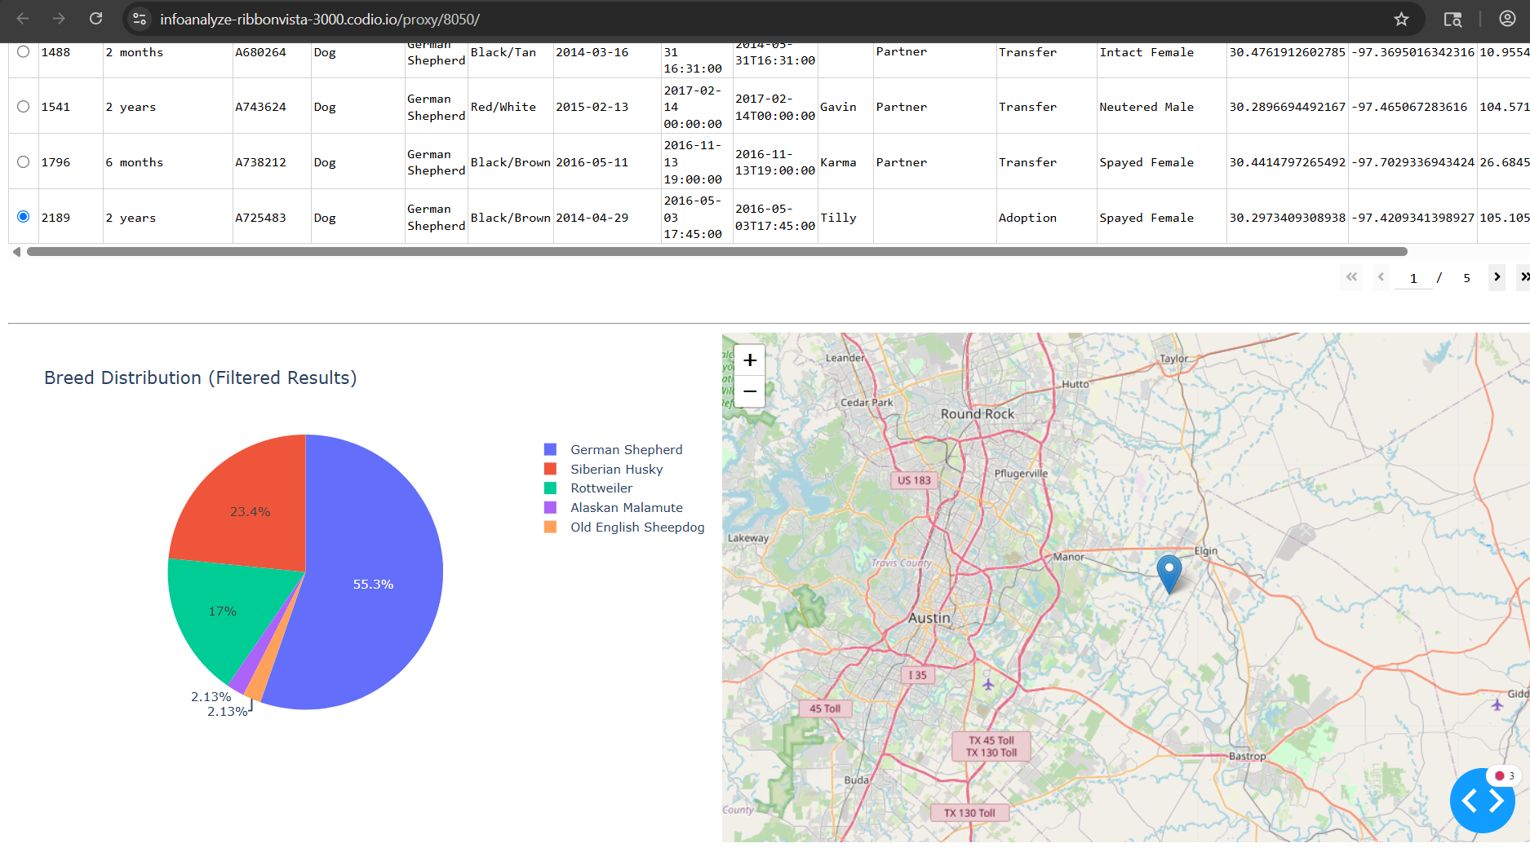
*This is with Mountain/Wilderness Rescue selected
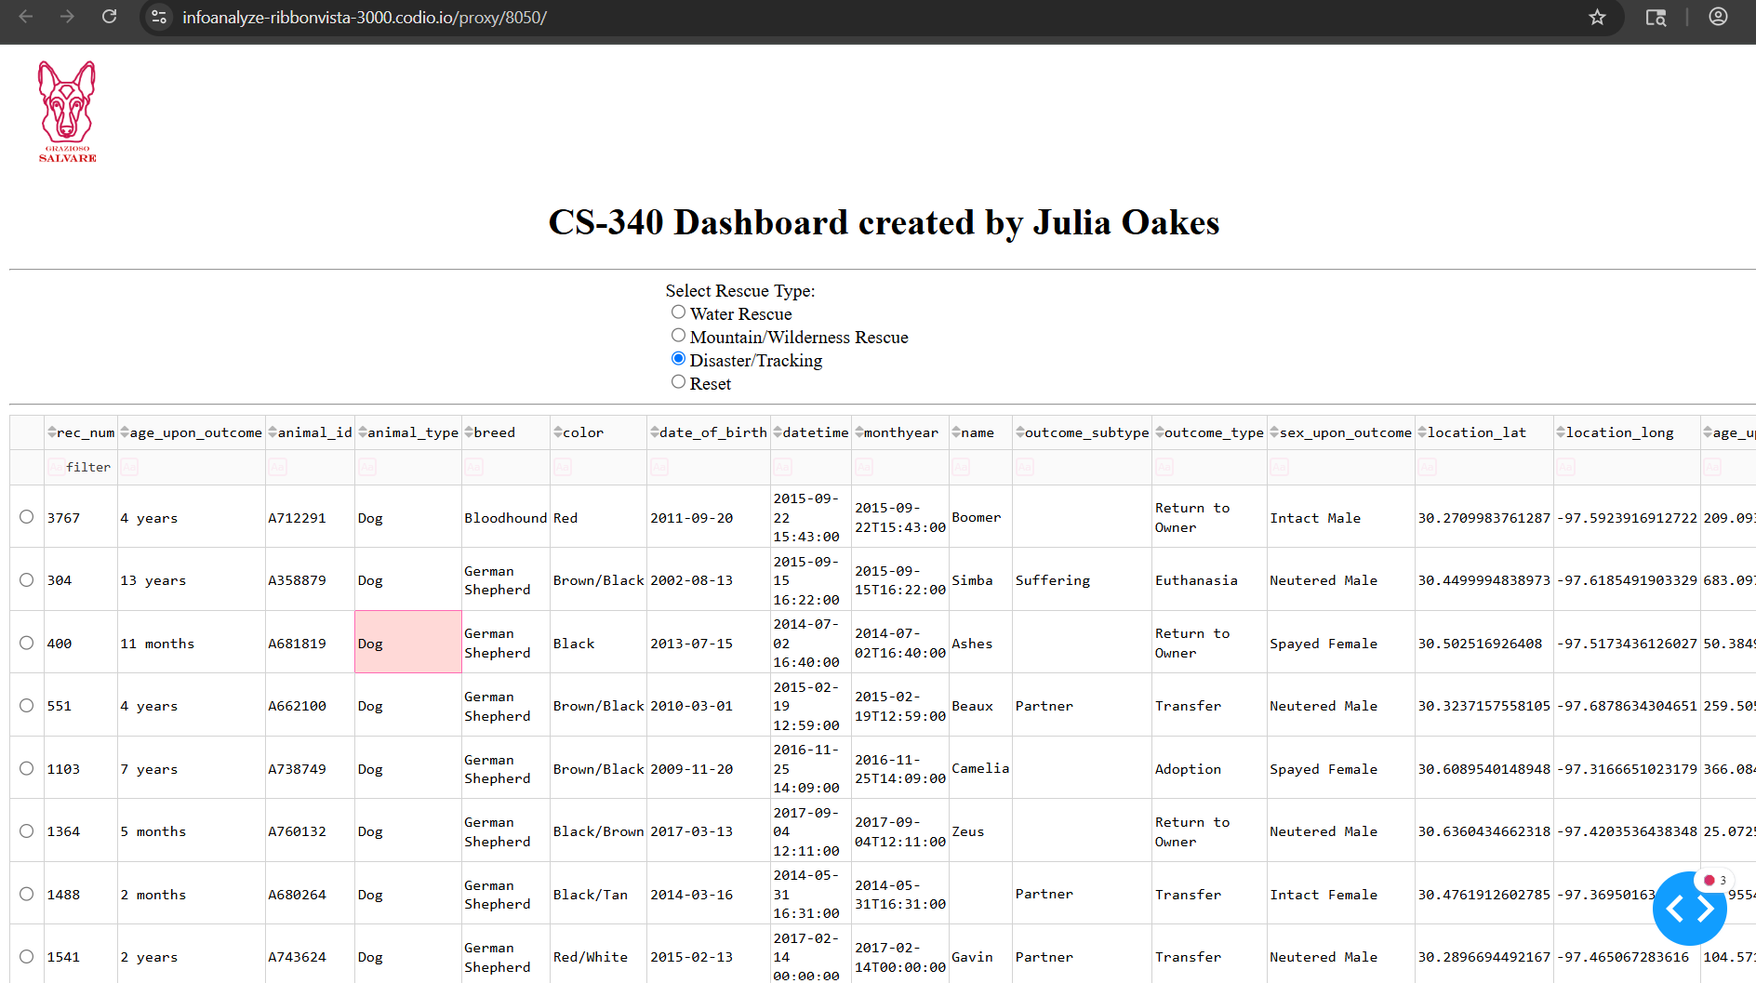
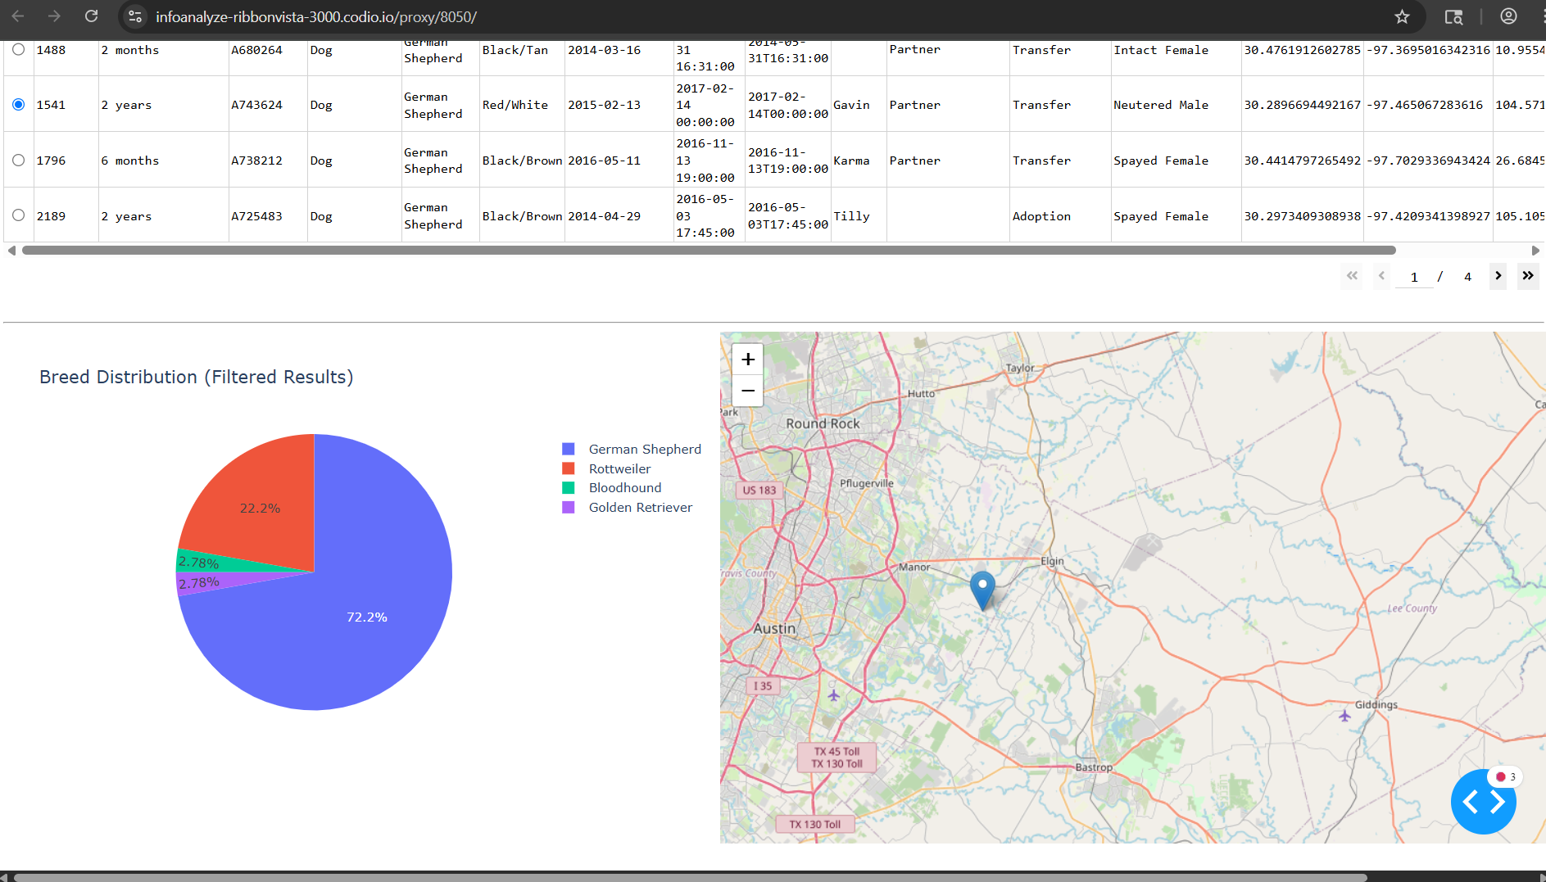
*This is with Disaster/Tracking Selected

Roadmap/Features (Optional)
Some potential future features that could be implemented would be the following:
-The ability to mark multiple dogs at the same time so their locations on the map can be viewed in tandem.
-A bar chart could be added for additional information to be displayed, like the ages of the dogs

Contact
Julia Oakes
Julia.oakes@snhu.com

